Front page

**TABLE OF CONTENTS**

1. **Introduction**
   1. Background
   2. Project Objectives
   3. Previous Research
   4. Applications
2. **Related Work**
   1. Recent Medical Image Analysis
      1. MRF and CRF
      2. Supervised learning techniques
      3. Application of KNN and improved model to medical image classification

**1 Introduction**

**1.1 Background**

The inspiration of our project comes from a competition on Kaggle: The RSNA 2022 Cervical Spine Fracture Detection Competition. In fact, over 1.5 million spine fractures occur annually in the US alone resulting in over 17730 spinal cord injuries. Among those spine fractures, the most common injury spot is around the cervical spines, which is the most important part of human spine controlling the signal transition from brain to the body.

**1.2 Project Objectives**

Human cervical spine consists of seven individual bones, which are given names C1, C2, up to C7 from top to bottom. This project aims to leverage machine learning techniques (mostly convolutional neural networks) to identify fractures on human cervical vertebrae, at both the level of a single vertebra and the entire patient. That means the model to be constructed should be able to not only detect the fracture for a patient overall, but also predict which vertebrae the fracture is located.

MRI is the ordinary method utilized to detect spine fracture. However, the entire set of MR images from a single patient could vary from 100 pictures to over 600 pictures. It could be tiring and boring for doctors to look through all the pictures to search for potential fractures. Moreover, the detection of fracture through human eyes is complicated. The MRI machine will record horizontal sliced image of human body into gray scale pictures, it is hard to be sure about the existence of fracture through a single picture, thus multiple slices from different location of the cervical spine is required for an authentic diagnose. Besides, fractures are not easily recognizable on grayscale images. It could be represented by a tiny white line hidden inside the bones. Thus, introducing machine learning methods into the analysis of those MR medical images is essential.

**1.3 Previous Research**

A successful and efficient machine learning model will highly improve the speed and accuracy of doctors’ diagnose on cervical spine fracture. Similar work has started many years ago with the spread of machine learning. And Convolutional Neural Network has been utilized in medical imaging analysis as well. For example, a specially designed CNN network to segment infant brain tissues based on multi-modality MR images[1.1]:

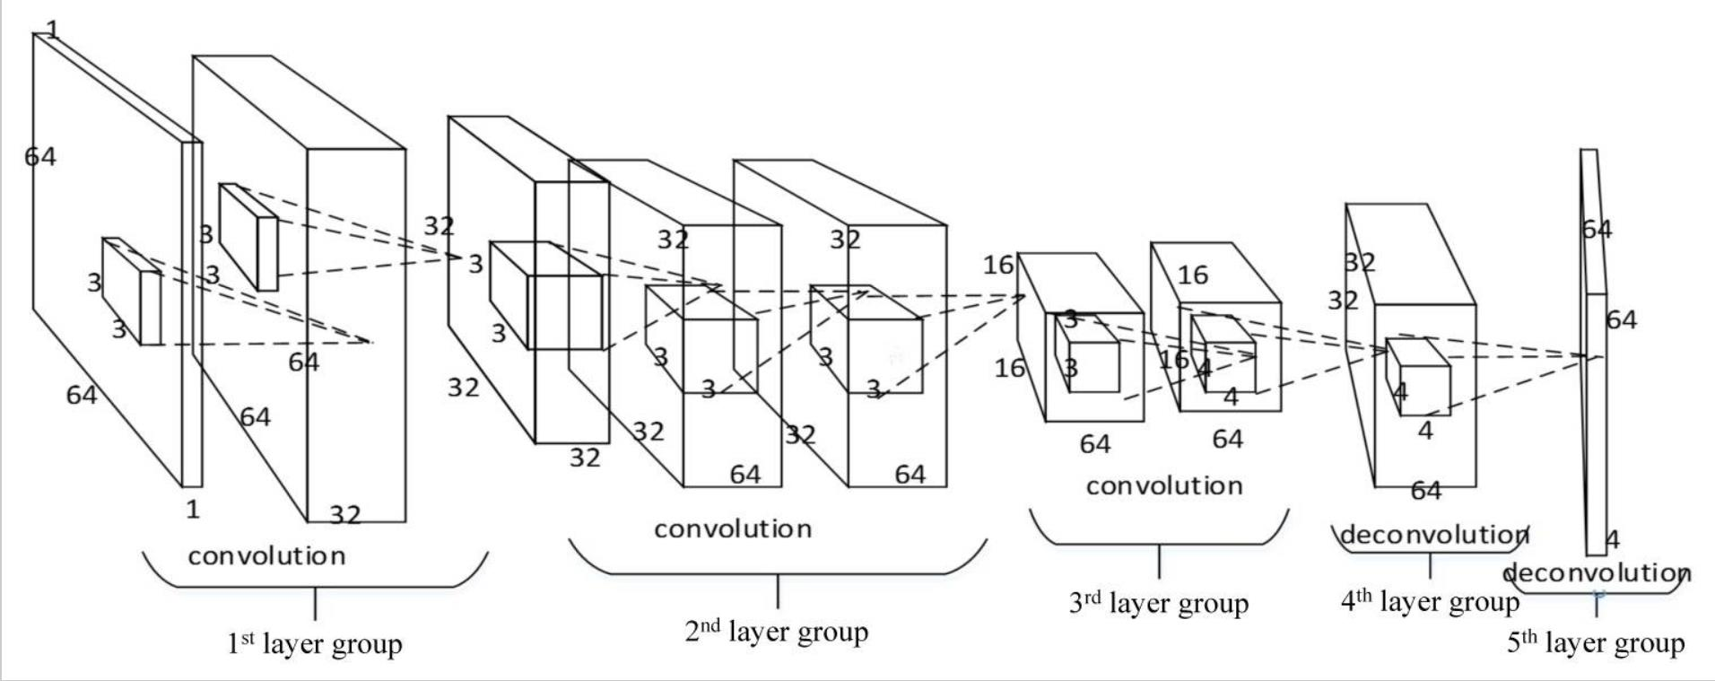

Figure 1: An architecture of the fully convolutional network used for tissue segmentation

In fact, the idea of using segmentation methods like CNN on MR images is one of the most popular topics in medical image analysis[1.2]:

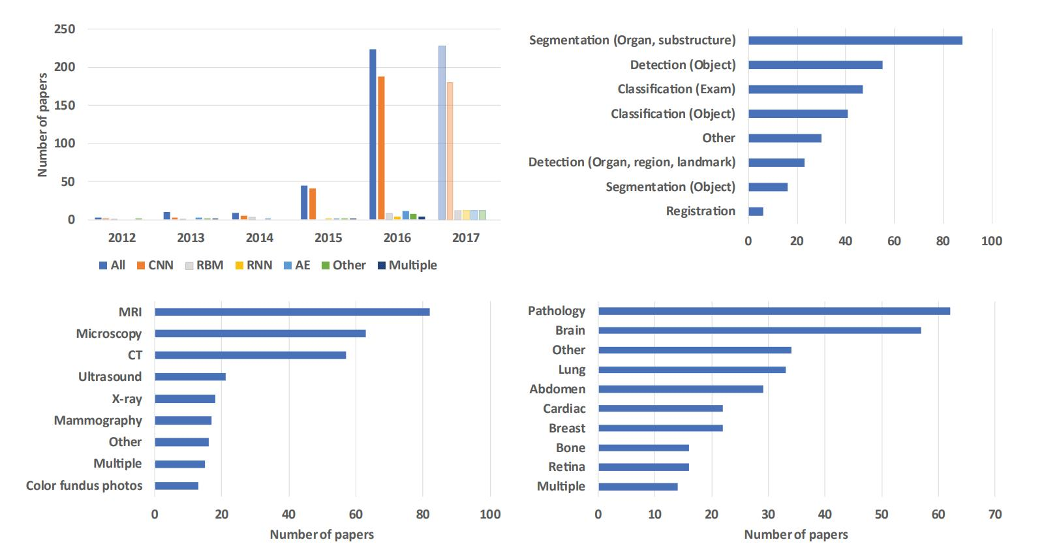

Figure 2: Breakdown of the papers included in this survey in year of publication, task addressed (Section 3), imaging modality, and application area (Section 4).

In our project, the segmentation of MR images is essential, we need to separate the cervical spine from the background and other structures of human skull like teeth, cheekbone, and jaw. More specifically, we have to further segment the MR images into different parts of the cervical spine from C1 to C7 because we want the result to indicate not only the existence of fracture but also the location of it. Based on those previous research results, we believe that CNN model will work perfectly on MR images and fulfill our segmentation requirements.

**1.4 Application**

The project will have a broad view of application, especially in medical and healthcare related areas. So far the design of medical imaging equipment is quite advanced and automatic. Radiologists are able to picture almost anywhere inside the human body with any kind of disease. However, the analysis of those medical images still highly relied on human work, due to the variety of form diseases could show and the huge aftereffect of misdiagnose. As a solution, machine learning could come in and do the redundant work for doctors and left the final decision of diagnose to human. The accuracy of machine learning models is absolutely high enough for an aid tool[1.3]:

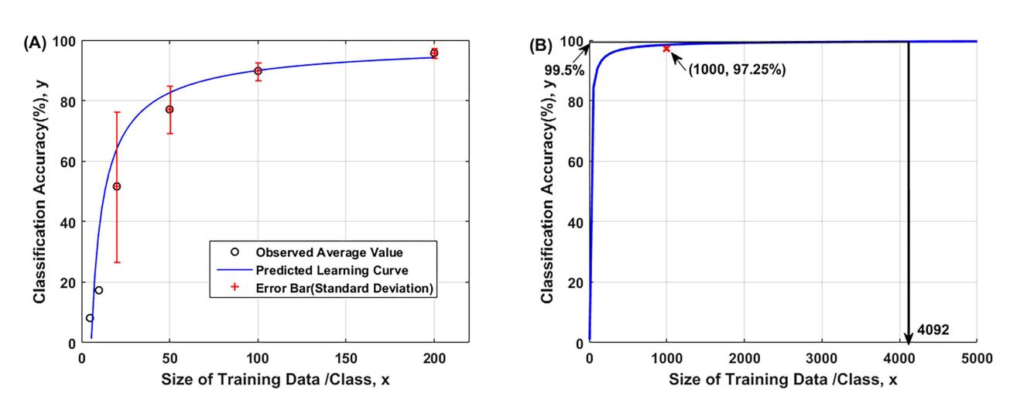

Figure 3: (A) The predicted learning curve and (B) tested result at large data set.

As presented above, machine learning models could reach an accuracy of over 99 percent in medical images classification with the support of sufficient amount of data. And in this project, we are provided with a wonderful dataset of 343GB of MR images collected from approximately 3000 CT studies. If our final detection accuracy reaches over 95 percent, it is good enough for actual Medical Applications.

**2 Related Work**

This chapter presents detailed background information and summarizes some past research relevant to the project topic.

**2.1 Recent Medical Image Analysis**

In this chapter, some existing techniques related to medical image analysis will be discussed and presented. In 2.1.1, 2.1.2 and 2.1.3, three mature medical image analysis techniques will be shown respectively, and their application scenarios and final performance will be detailed analyzed. These current technologies also serve as the basis and improvement of our project to help.

**2.1.1 MRF and CRF**

The conditional probability model is a classic model in machine learning, and it also has excellent performance in medical image analysis. Pathological image analysis is an important procedure in the clinical diagnosis of various diseases. To improve the accuracy and objectivity of diagnosis, more and more intelligent systems are proposed today. Among these methods, random field models play an integral role in improving survey performance. A comprehensive overview of pathological image analysis based on Markov random fields (MRF) and conditional random fields (CRF), two popular random field models, is presented in this review.[4] In this article he first introduces the background of two random fields and pathological images. And summarizes the basic knowledge of MRFs and CRFs from modeling to optimization. The authors then provide a comprehensive review of recent studies on MRF and CRF for pathological image analysis. Method transfer between CAD domains is also discussed.

In the analysis of medical images, accurate image segmentation is often required, and the technology mentioned here is needed at this time. such as in [5], a four-step image segmentation process is employed to classify four categories of teratoma tissues. First, the image segmentation process is formulated in the Bayesian framework. Second, a set of hidden real-valued random fields designing a given segmentation probability is introduced. In order to produce smooth fields, a Gaussian MRF (GMRF) prior is assigned to reformulate the original segmentation problem. Third, the form of total variation of isotropic vectors is adopted. Finally, aiming to conquer the convex optimization problem that makes up the MAP inference of hidden fields.

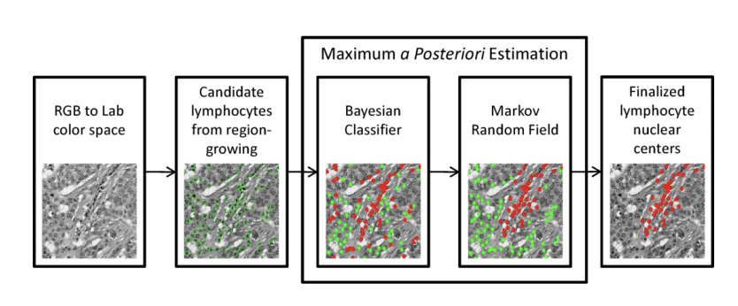

Fig. 1. the main five steps in the automated lymphocyte detection framework. [6].

**2.1.2 Supervised learning techniques**

Supervised learning is to learn a function (model parameters) from a given training data set, and when new data arrives, the result can be predicted according to this function. The training set requirements for supervised learning include input and output, which can also be said to be features and targets. Supervised learning is the most common classification. It also has the ability to classify unknown data. The goal of supervised learning is often to get the computer to learn the classification system we have already created.

Supervised quantification approaches can not only assist in diagnosis, but are also increasingly used to predict future disease onset or progression. Models are then trained on data from longitudinal studies in which the disease status years after the acquisition of the baseline image is known. For example, H. C. Achterberg [7] showed that hippocampal shape classification in a healthy elderly population is predictive of onset of dementia symptoms up to ten years later. van Engelen [8] used multivariate sparse Cox regression to take time to event into account in the model and found that changes in plaque texture and volume in ultrasound images of the carotid artery could predict future vascular events better than traditional risk factors could.

The main obstacle currently preventing wider use of machine learning in medical imaging is a lack of representative training data. While supervised learning techniques have shown much promise in relatively constrained experiments with standardized imaging protocols, their performance may quickly deteriorate on new images that are acquired under slightly different conditions. These techniques operate under the assumption that both train and test datasets are random samples drawn from the same distribution. This paper [9] approach to cope with these issues, which is gaining increasing interest, is to apply transfer learning or domain adaptation techniques. They discern two classes of approaches that both aim to make train and test distributions more similar: weighting and feature space transformation techniques. In their study, they found that a weighted-based transfer learning approach can significantly improve the classification accuracy of MRI segmentation problems when there are few labeled target samples.

**2.1.3 Application of KNN and improved model to medical image classification**

Medical diagnosis usually requires a large amount of data to support, but generally only some diseases have a large amount of data. The small amount of data limits the use of most neural networks in medical diagnosis. For small datasets, KNN is a good method. However, in traditional KNN, the classifier and feature extractor are separated, which makes KNN unable to extract targeted features. This paper [10] proposes an improved KNN—deep KNN, which combines a classifier and a feature extractor.

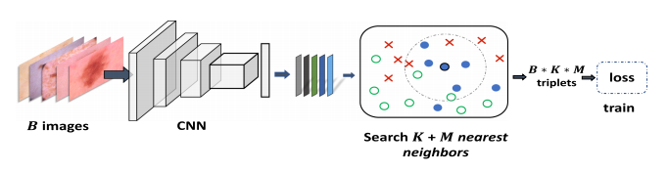

Fig. 2. The work step of deep-KNN in training

Similar to DNNs, training can be accelerated with stochastic gradient descent (SGD). But each iteration needs to re-find KNN and MNN of all samples, which is too expensive. The iterator is updated every time a mini-batch of samples is trained, and for each sample, KNN and MNN are only found in that mini-batch. The traditional idea of KNN is to make the distance between any two points in the same category smaller than the distance between any two points in different groups. The idea of Deep KNN is that the distance between any point and the K nearest neighbors of the same classification is less than the distance between the point and the M nearest neighbors of different classifications. The purpose of traditional KNN is to make the distribution of various types of data more aggregated, and the purpose of Deep KNN is to separate the distribution of different classes, so that the data and its K nearest neighbors belong to the same class, without requiring the data of each class to be tightly clustered. Deep KNN is easier to train.

**2.2 Deep Learning for Computer Version**

**3.2 Evaluation Metrics**

The major objective of this project is to detect the existence of fractures on human cervical spines, not only on a patient-level but also on the vertebra-level. Therefore, the two most essential evaluation metrics are the fracture prediction accuracies on the patient-level and the vertebra-level. That is to say, it is desirable to measure the proportion of accurately predicted patients with respect to all the patients, as well as the proportion of accurately predicted vertebrae with respect to all the vertebrae. Since each patient has 7 vertebrae on the cervical spine, the total number of test cases of vertebrae is 7 times that of the patients.

Since the total number of patients with cervical spine fractures is similar to that of patients without any fracture in the dataset, prediction accuracy can be regarded as an appropriate evaluation metric. However, when it comes to the fracture detection on the vertebra-level, the problem of class imbalance occurs. Most vertebrae individually has only a small proportion of patients having fractures, leading to highly imbalanced prediction classes in this particular task. Hence, f1-score might be a better evaluation metric than accuracy for fracture detection on the vertebra-level, and these two metrics will both be applied to judge the model performance.

Apart from the main task to detect fractures, this project also involves several subtasks which require another few metrics for model performance evaluation purpose. For vertebrae detection, the prediction accuracy of vertebrae index is adopted. For fracture localization, the Intersection over Union (IoU) is chosen as the metric.

**3.3 Project Workflow**

Fig X. The project workflow diagram.

The project is roughly divided into five phases (Fig. X). In the first stage, CT scan images are transformed to improve the model performance in subsequent stages. The second stage focuses on the identification of the vertebrae that are present on each slice. In the third stage, the existence of fractures are detected on both the patient-level and the vertebra-level. The fourth stage attempts to detect the exact location of the fracture on a slice that has been identified as fractured. The final stage visualizes the human cervical spine in a 3D space and highlights the locations at which fractures are detected. This project is more concentrated on the fracture detection task, thus the second and the third phases are of the most interest.

Every stage of the project requires its own methodologies to accomplish the goal. The following five subsections elaborate the detailed procedures adopted in each phase.

**3.3.1 Data Preprocessing**

CT scan images of cervical spines are of great importance to this project, since most tasks are related to image processing and analysis. In particular, project stages 2, 3, and 4 all expect images as input to their models to extract features for further analysis. Considering the insufficiency of training images in some of the experiments and the possible noise that might exist on the slices, it is vital to consider techniques that help to alleviate these issues.

**3.3.1.1 Image Augmentation**

As investigated previously, among all the 2019 patients in the dataset, only 87 of them have vertebrae indices annotated on the slices, and only 239 of them have bounding boxes drawn to denote the location of fractures. The insufficient training image samples might become a potential problem for vertebrae detection and fracture localization (i.e., project stage 2 and stage 4). Therefore, it can be advantageous to augment the dataset to generate more training samples.

Image augmentation is a technique that can be adopted to produce extra training images based on the current ones. Random rotation, shifting, and flips can be applied on the existing images to create new ones with the same labels. By augmenting the training dataset, the models are more likely to learn more useful features from images and tend to give more accurate predictions.

However, some problems with this method might impede its effectiveness. One of the concerns is the increasing training time. If only the transformed images are forwarded to the models, leaving the original images out, the actual number of training images does not increase. If both the original and transformed sets of images are fed to the models, model accuracy might be improved but the training time will rise significantly, which can make this technique too inefficient to carry out.

Another possible problem is that, since the CT scan images in the dataset are well aligned, they might be sensitive to certain transformations. For instance, as can be observed from the example slices (Fig. X), the position of cervical spine is almost constant in each slice, and the shape of the vertebrae is not perfectly symmetric. Blindly applying image shifting or flipping might induce negative effects, hence performing image data augmentation requires specical care in this circumstance.

**3.3.1.2 Image Masking and Segmentation**

Due to possible noises in the images, it might be contributive to apply masking or segmentation on the images for noise reduction.

Fig. X. Examples of masked image slices.

Image masking tries to identify the background part of the images, and set all the pixels in that part to zeros (Fig. X). This method eliminates the background noises but requires another well-trained model for background identification.

Fig. X. An example of segmented image.

Image segmentation attempts to separate each slice into several sections (Fig. X), each denoting a specific type of object such as background and vertebrae, or even each individual type of vertebrae. Then, some other process like averaging can be applied to each identified region to reduce noises.

Some relatively trivial methods for masking and segmentation include simple thresholding and K-means clustering. Since CT scan images are essentially grayscale images with only a single channel, K-means clustering is basically finding K-1 splits to separate the pixel values.

Advanced semantic segmentation models involve the usage of well-annotated segmented dataset, which is available in this project, and also deep learning models such as SegNet, U-Net, DeepLab, Mask-RCNN, etc.

One of the potential problems in simply taking the average of each segmented region is the information loss. The variation of pixel values in some certain regions might play an important role in the future prediction tasks, thus identifying a region and averaging its pixel values may not necessarily be a proper action.

**3.3.2 Vertebrae Detection**

Each of the 2019 patients has the corresponding hundreds of image slices. However, most of them do not have vertebra index annotated for each slice. Since traditional 2D CNNs only take a single image as input, which means that each slice of a patient is treated independently by the model, even if the model successfully detects the fracture in some slice of a patient, it is impossible for the model to tell which vertebra this fracture is located at without the vertebra index of that slice. Hence, the vertebra-level fracture detection can hardly be conducted.

To get prepared for the fracture detection task in the next stage, a image dataset with vertebrae labels is needed. Fortunately, 87 patients have their CT scan images annotated with vertebrae indices, which can be used to train a vertebrae detection model that can be applied to infer the vertebrae probability tags of the slices of all the remaining patients, indicating the probability of some vertebra being in some slice.

Two approaches are proposed in the following subsections to predict the vertebrae in each slice.

**3.3.2.1 Vertebrae Detection with Images Only**

The rationale of the vertebrae detection model with only images as input is straightforward. What is available now is a set of image slices, each with its corresponding vertebrae labels. The model has it input being is a 2D image and the output being a 7-dimensional vector, which denotes the probability of each vertebrae being present on the input slice. Note that this vertebrae detection task is essentially a multi-label classification instead of multi-class classification, since multiple vertebrae can be present simultaneously on the same slice. Therefore, each entry of the 7-dimensional output vector, which has to be a number between 0 and 1, independently corresponds to the probability of that vertebra, without the constraint of summing up to one. Hence, a model can be designed as illustrated in Fig. X.

Fig. X. Vertebrae detection model with images only.

First of all, the transformation has to be conducted on the input images before forwarding them to the CNN. The procedures of this step include pixel value rescaling, image resizing, image augmentation, and noise reduction.

After changing the images into a uniform format, they are ready to be fed to a backbone CNN model. This model serves as a feature extractor, which produces an n-dimensional feature vector of the input image. Employing the technique of transfer learning, off-the-shelf CNN models, whose weights are obtained from pre-training by a some large-scale image dataset like ImageNet, can be applied here for the task of vertebrae detection. The options for the backbone CNNs include VGG, ResNet, MobileNet, DenseNet, EfficientNet, vision transformer, etc., and their performance remains to be evaluated by experiments. In section 3.3, a backbone CNN refers to any pre-trained CNN model that can be applied for feature extraction.

The resulting n-dimensional feature vector is then forwarded to a fully connected neural network, which generates a 7-dimensional vector with entry values being any real numbers. This vector is treated as the log odds of the presense of the seven vertebrae. By applying another sigmoid function of the log odds, the final 7-dimensional vertebrae probability vector with all values in [0, 1] can be derived. The loss of the model is defined as the binary cross entropy between the predicted probability vector and the true vertebrae label vector.

Training the model by back propagation using the image slices of those 87 patients, a model to predict the vertebrae probabilities of any image slice can be obtained. This model is then leveraged to infer the vertebrae in all the remaining images.

**3.3.2.2 Vertebrae Detection with Extra Attributes**

Since all the images in the dataset are in DICOM format, which contains some extra metadata apart from only the image pixel values. The available metadata include the slice thickness, the slice index (which can be used to calculate the ratio of the current slice in that patient from top to bottom), and the 3D coordinates of the slice position.

Among these extra attributes associated with each image, slice ratio and the z-coordinate of the slice position are of great importance to infer the vertebrae that the current slice is showing. Since the CT images are scanned in order from top to bottom of a patient’s neck, the slice ratio and the z-coordinate are perfect indicators of vertebrae indices. Therefore, a model that can take consideration of not only the slice image, but also these extra helpful attributes to predict vertebrae indices is desired. The technique of multimodal learning can be leveraged to integrate these attributes into the model.

Fig. X. Multimodal learning for vertebrae detection.

As demonstrated in Fig. X, a separate neural network is incorporated in the original model to extract features from the attributes of the images. Now, the input to this model contains both an image and the relevant attributes of that image such as the aforementioned ones. Hopefully, by employing these additional features, the model prediction accuracy can be further improved.

**3.3.3 Fracture Detection**

Now that each image slice has inferred vertebrae labels attached to it, fracture detection can finally be carried out. Note that these vertebrae labels are not binary, but are the probability of each vertebrae being present on the slice.

Three models are put forward in the subsequent subsections for the fracture detection task.

**3.3.3.1 Fracture Detection with Images Only**

The most intuitive method to determine whether a patient has fractures on any cervical spine vertebrae is to first design a model to predict the existence of fracture on a single slice (Fig. X).

Fig. X. Fracture detection model with images only.

This model again takes a 2D image slice as the input, but the output is a single number in [0, 1] indicating the probability of fracture on the input image.

How to determine whether an image actually has fracture or not? This is the true label for the image and must be well-defined for the model training purpose. The dataset only provides fracture information for the patient overall and upto the vertebra-level, without denoting the existence of fractures on each slice. But in the previous stage, all the vertbrae probabilities have already been inferred for the training images of all the 2019 patients. Utilizing the inference results, we can manually label each slice as having fracture or not by first looking at which vertebrae this slice has (if the probability of some vertebra exceeds some threshold, say 0.5, then the slice is said to have that vertebra), and then checking whether any of the existing vertebrae has fractures.

After assigning a fracture label to each of the training image, the loss can be defined as the binary cross entropy between the predicted fracture probability and the “true” fracture label.

The model can thereby be trained with back propagation.

Now that we have the individual probability of fracture on each slice of a patient, how can it be determined whether this patient has fracture on his cervical spine overall or on any one of his vertebrae? Here, the vertebrae probabilities of each slice are to be utilized once again. For each patient, the predicted probability that vertebra Cj is fractured is given by the weighted average of fracture probability of all the slices, i.e.,

in which is the probability of fracture on the i-th slice of the patient, denotes the probability that vertebra Cj is on slice i.

With the individual probability of fracture on each vertebra, the overall fracture probability of this patient is given by the probability of having fracture on any of the 7 vertebrae, i.e.,

assuming the fracture on each vertebra is independent from each other. Though the independence assumption might be too naïve to be correct, this method is still adopted to calculate the overall fracture probability of patients at this time.

**3.3.3.2 Fracture Detection by Multimodal Learning**

Another model architecture leverages the idea of multimodal learning. This model incorporates the vertebrae probabilities of each image into the input to generate fracture probability predictions (Fig. X).

Fig. X. Multimodal learning for fracture detection.

Having the vertebrae labels of the image together with the image itself as the input, the model is not only able to judge whether the input image slice has fracture or not, but also to deduce the probability of fracture on each vertebrae of the patient. The output of this model is not the probability of fracture in this slice, but probability of fracture in each vertebra of the patient.

Although it might sound unreasonable for a model to give fracture predictions to all the vertebrae by judging from only a single slice image, the vertebare labels enable the model to do so in some sense. Furthermore, even if the model cannot generate accurate fracture predictions on the vertebrae that are not present in the current slice, the final predictions can still give a satisfactory result since they are determined by aggregating all the slices of a patient. The detailed procedures will be elaborated later in this section.

With this model, there is no need to perform extra computation to generate true output labels as in the previous section, since the original dataset fracture labels of each patient can directly be used as true output of the model.

Again, since this is a multi-label classification problem, sigmoid function should be used to get the fracture probabilities. This time, weighted binary cross entropy is chosen as the loss function, and the weights are just the vertebrae probabilities. That is to say, only the vertebrae that are visible in the current slice requires an accurate fracture probability prediction. Inaccurate predictions on other vertebrae that are not in the current slice will not be penalized.

By updating the model weights with back propagation, a model that can produce a 7-dimensional fracture probability vector from each image slice of a patient can be trained.

Finally, the probability of that fracture exists on the vertebra Cj of the patient is determined by the weighted average of the vertebra-level fracture probability of all slices, i.e.,

in which is the probability that vertebrae Cj has fracture judging from the i-th slice of the patient, denotes the probability that vertebra Cj is on slice i. This method alleviates the potential issue of prediction inaccuracy mentioned previously in this section, since even if the model gives a high predicted fracture probability on some vertebra (i.e., a high value of ) that is not present on the current slice, the low vertebra probability assigned to this slice (i.e., a low value of ) can refrain the final weighted average from growing too large for this vertebra Cj.

Similar as the aforementioned approach, under the independence assumption, the overall fracture probability of this patient is given by

**3.3.3.3 Fracture Detection by Multi-task Learning**

Another alternative for fracture detection employs the technique of multi-task learning. This method is highly similar to the multimodal learning approach mentioned in the previous section, with only a small difference on the model architecture.

Fig. X. Multi-task learning for fracture detection.

Instead of treating the vertebrae probabilities as input, multi-task model consider them as output. So the input to this model is just a single image, while the output contains both the fracture probabilities and the vertebrae existence probabilities (a 7 × 2 = 14 dimensional output).

Multi-task learning enables the model to retrieve information from the image to solve multiple tasks. Since the tasks are highly related, (e.g., predicting the vertebrae probabilities and the fracture probabilities on the vertebra-level), the model learns more important features from the images for fracture prediction.

The loss function of this model is defined as the sum of two parts. The first one is the same as what has been illustrated in the previous section (i.e., the weighted average binary cross entropy of fracture probabilities), while the second one is binary cross entropy of the vertebrae predictions.

The approach to derive the final predictions on the vertebrae fracture probabilities and the overall patient fracture probability are exactly the same as that introduced in the last section.

**3.3.4 Fracture Localization**

Among 2019 patients, 239 have bounding boxes in their image slices indicating the position of a fracture. Using these annotated images as training data, a fracture localization model can be obtained. Models such as Faster R-CNN, R-FCN, and SSD can be all be applied for fracture localization purpose.

The fracture detection model introduced in section 3.3.3.1 can be used to infer whether a single slice has fracture or not. All the slices that have been identified as fractured can be forwarded to the localization model to determine where the fracture is. By this means, this project goes beyond simply predicting the existence of fractures on a cervical spine. The exact position of fractures in 3D coordinate system can possibly be disclosed.

**3.3.5 Cervical Spine Visualization**

In the final stage of the project, it is expected to have the fracture locations displayed in a 3D coordinate system. Since all the slices of a patient share a uniform width and height, and the z-coordinates can also be inferred from the slice index, the 3D cervical spine can be recovered from the slices. Moreover, the fracture locations given by models in the previous stage can also be identified on the same 3D plot, which hopefully can help to visualize the postion of fractures in a 3D space.

**References**

[1] Shen D, Wu G, Suk HI. Deep Learning in Medical Image Analysis. Annu Rev Biomed Eng. 2017 Jun 21;19:221-248.

[2] Geert Litjens, Thijs Kooi, Babak Ehteshami Bejnordi, Arnaud Arindra Adiyoso Setio, Francesco Ciompi, Mohsen Ghafoorian, Jeroen A.W.M. van der Laak, Bram van Ginneken, Clara I. Sánchez, A survey on deep learning in medical image analysis, Medical Image Analysis, Volume 42, 2017, Pages 60-88, ISSN 1361-8415.

[3] Junghwan Cho, Kyewook Lee, Ellie Shin, Garry Choy, Synho Do. D How much data is needed to train a medical image deep learning system to achieve necessary high accuracy? arXiv. 2016 Jan 7.

[4] Y. Li κ.ά., ‘A comprehensive review of Markov random field and conditional random field approaches in pathology image analysis’, Archives of Computational Methods in Engineering, σσ. 1–31, 2021.

[5] A.N. Basavanhally, S. Ganesan, S. Agner, J.P. Monaco, M.D. Feldman, J.E. Tomaszewski, G. Bhanot, A. Madabhushi, IEEE Transactions on Biomedical Engineering

57(3), 642 (2009)

[6] J. Bioucas-Dias, F. Condessa, J. Kovaˇcevi´c, in Image Processing: Algorithms and Systems XII (2014), p.90190P

[7] H. C. Achterberg κ.ά., ‘Hippocampal shape is predictive for the development of dementia in a normal, elderly population’, Human brain mapping, τ. 35, τχ. 5, σσ. 2359–2371, 2014.

[8] A. van Engelen κ.ά., ‘Three-dimensional carotid ultrasound plaque texture predicts vascular events’, Stroke, τ. 45, τχ. 9, σσ. 2695–2701, 2014.

[9] M. de Bruijne, ‘Machine learning approaches in medical image analysis: From detection to diagnosis’, Medical Image Analysis, τ. 33, σσ. 94–97, 2016.

[10] J. Zhuang, J. Cai, R. Wang, J. Zhang, και W.-S. Zheng, ‘Deep kNN for medical image classification’, στο International Conference on Medical Image Computing and Computer-Assisted Intervention, 2020, σσ. 127–136.